OSYS 1000 Exercise 13

**UNIX**

# Instructions

**This exercise is a series of steps you will complete on the CentOS Terminal interface. Therefore, you must have your virtual machine installed as per the “CentOS Installation” video.**

1. Perform some Internet research to see how to install and setup the Apache2 web server daemon on CentOS 7.
2. We are not going to bother with either the script command or creating an executable shell script for today. You can simply take screenshots of installation/setup of Apache (i.e. **Steps 3 – 9**) and store them in a Word document (e.g. “Ex13_Mike_Crocker.docx”).
3. Install Apache2.

sudo yum -y install httpd

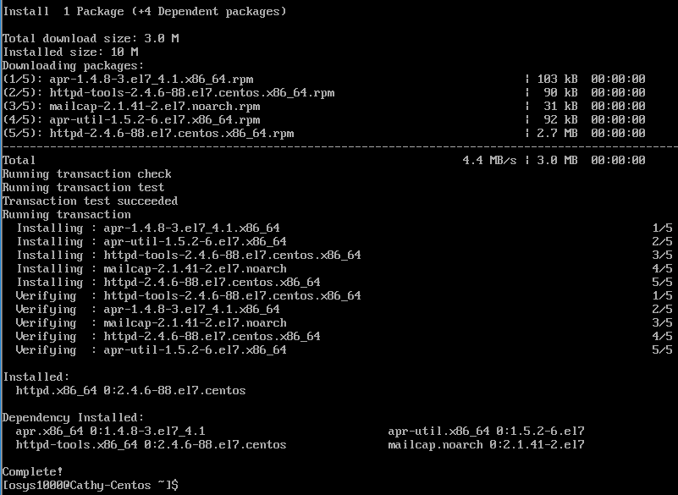

1. Setup the Apache service. **Make sure that Apache is set up to run on system startup.**

sudo firewall-cmd –permanent –add-port=80/tcp

sudo firewall-cmd –reload

sudo systemctl start httpd

sudo systemctl enable httpd

sudo systemctl status httpd

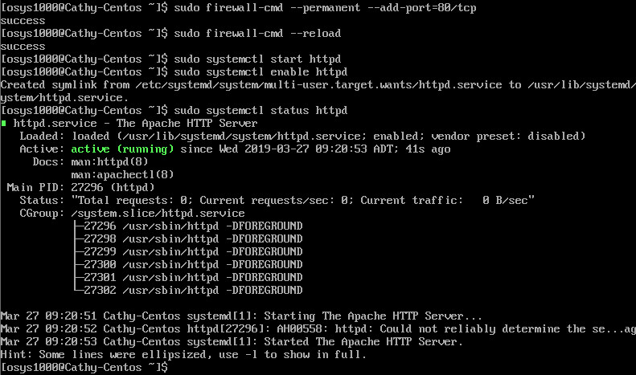

1. Reboot the system and verify that Apache is running by reporting its service status.

sudo systemctl status httpd

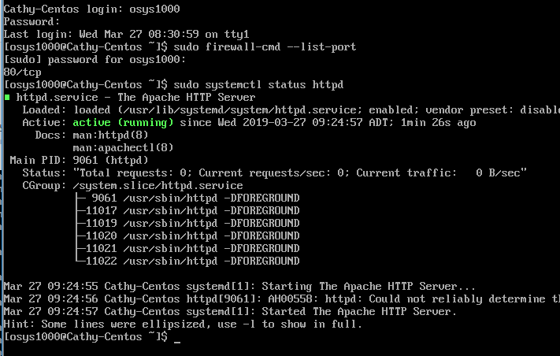

1. Make sure that the web server port is added as an exception on the Firewall. The firewalld service should already be running after installation but you will need to add a rule to allow HTTP connections. If the Apache installation instructions that you are following did not mention allowing web access through the firewall, then the following link may be of help:

sudo firewall-cmd –list-port

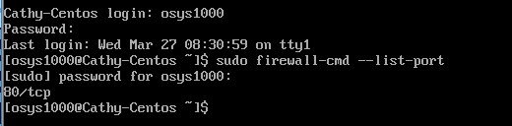

<https://www.digitalocean.com/community/tutorials/how-to-set-up-a-firewall-using-firewalld-on-centos-7>

1. Set up a simple, custom default index.html page for Apache with your name in a H1 header.
2. Report the IP address of your CentOS machine.

ip addr

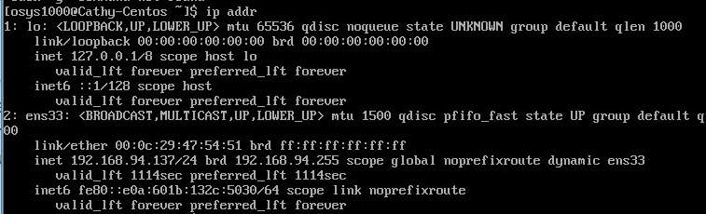

1. Try to view your page by accessing that IP address in a web browser from the host Windows lab machine.



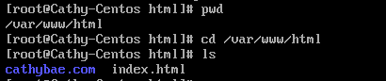

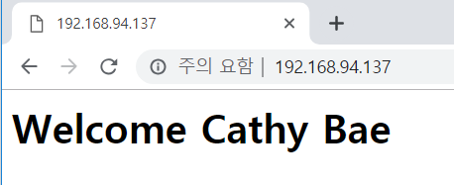

1. Post the Word document with your screenshots to the D2L Dropbox for the thirteenth in-class exercise in order to obtain credit for completing it.
2. That’s it.

n